IT HAPPENS @ RAALE #12
HelpDesk 360
Enterprise IT Support & Incident Management System
Project Report
Team / Members | [Add team name and member names]
Version | 1.0.0
Report date | 15 October 2026
Stack | Spring Boot 3 REST API · Astro + React 19 · SQLite (Supabase PostgreSQL ready) · JWT
Repository | [Add GitHub link]

1. What we built
HelpDesk 360 is a web-based IT support system. Employees raise tickets when something breaks, and technicians pick them up, work on them and close them.
We built three main pieces:
• A Java 21 / Spring Boot 3 backend with JWT authentication and proper role checks
• An Astro + React 19 frontend with a clean black-and-white corporate look
• SQLite as the default database (with the config already prepared for Supabase PostgreSQL if we ever want to switch)

What actually works right now
• Login for both employees and technicians
• Ticket submission
• Personal ticket tracker for employees
• Technician queue with priority and status filters
• One-click claim
• Status changes that get logged in an audit history
• Live dashboard numbers pulled straight from the database
• 6 out of 6 automated tests passing, plus one full browser walkthrough
We also seeded the database with 150 real tickets from a multi-country support dataset and 29 technician accounts.

What still doesn’t work
• No email or in-app notifications
• SLA fields from the dataset are just sitting there — no actual timers or breach alerts
• We never fully tested the Supabase path end-to-end
• Negative testing and security testing are still pretty thin

Architecture (simple version)
Frontend: Astro 7.3 + React 19 + TypeScript + Tailwind CSS v4
• Employee side — dashboard, ticket form, “My Tickets”
• Technician side — support queue, claiming, status changes, history timeline
Backend: Java 21 + Spring Boot 3.2.5 + Spring Security 6 + Hibernate
• Controllers → Services → JWT filter → Repositories
Database: SQLite locally (zero setup). Same code works with Supabase PostgreSQL if we point it there.
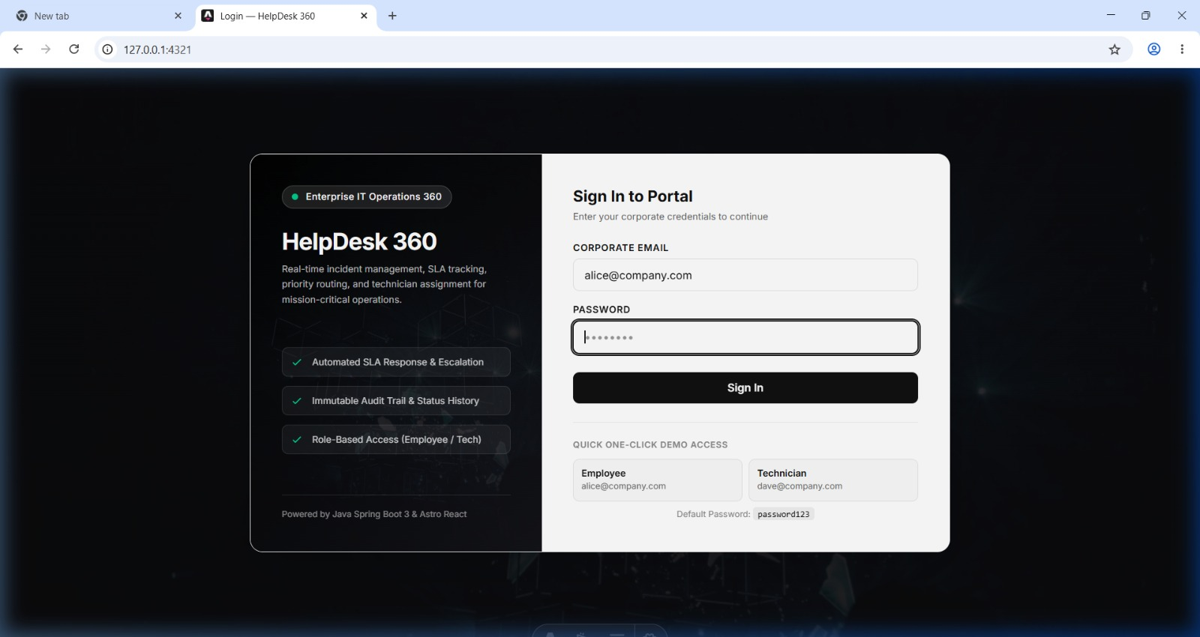
Figure 1. Sign-in screen with one-click demo access for the Employee and Technician roles.
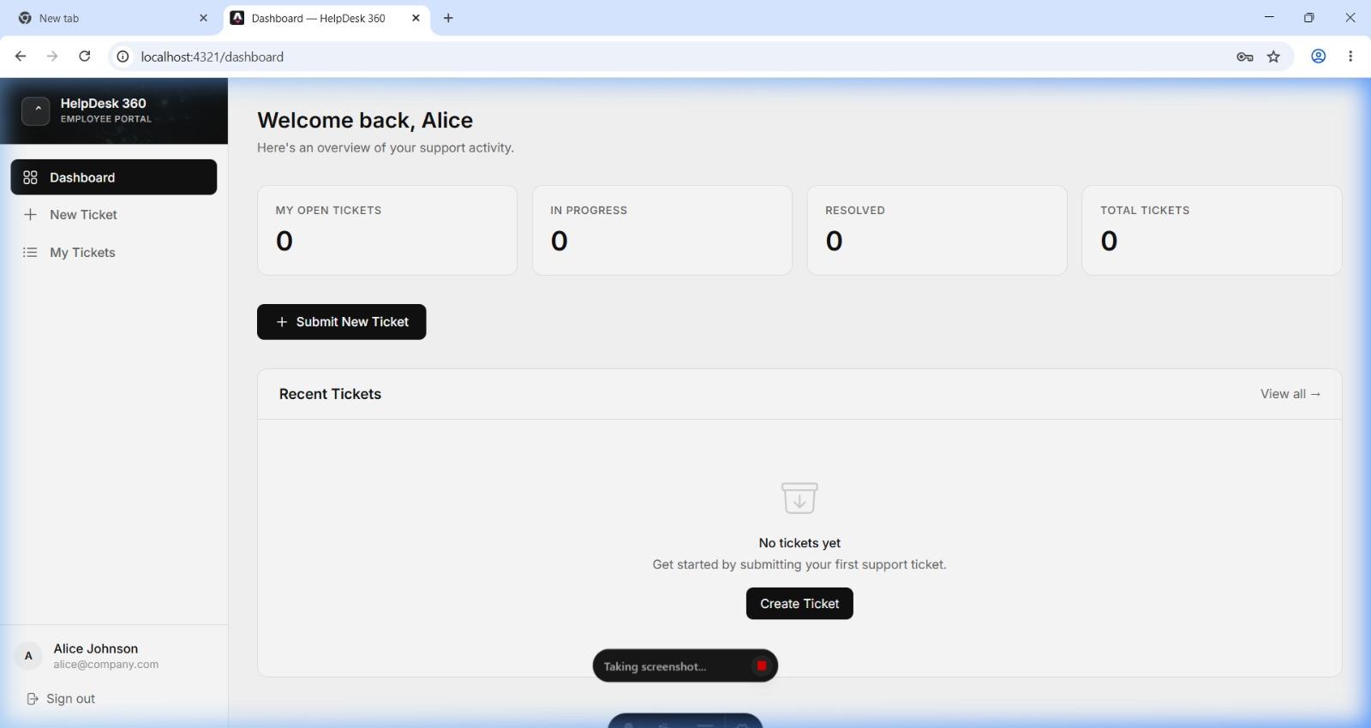
Figure 2. Employee dashboard: personal ticket counts and recent tickets for the signed-in user.

2. The ticket logic

2.1 Submission
Rule | Enforced in | How
Title, description, category and priority are required | Frontend | Form validation with inline errors on the create page
Category must be one of the five options; priority one of the four | Frontend + Backend | UI selection cards + Java enums on the server
Only logged-in users can submit | Backend | POST /api/tickets restricted by Spring Security
Every ticket must have a reporter | Database | reported_by is a NOT NULL foreign key
New ticket starts as OPEN and gets a first history entry | Backend | Service layer writes the initial status_history row
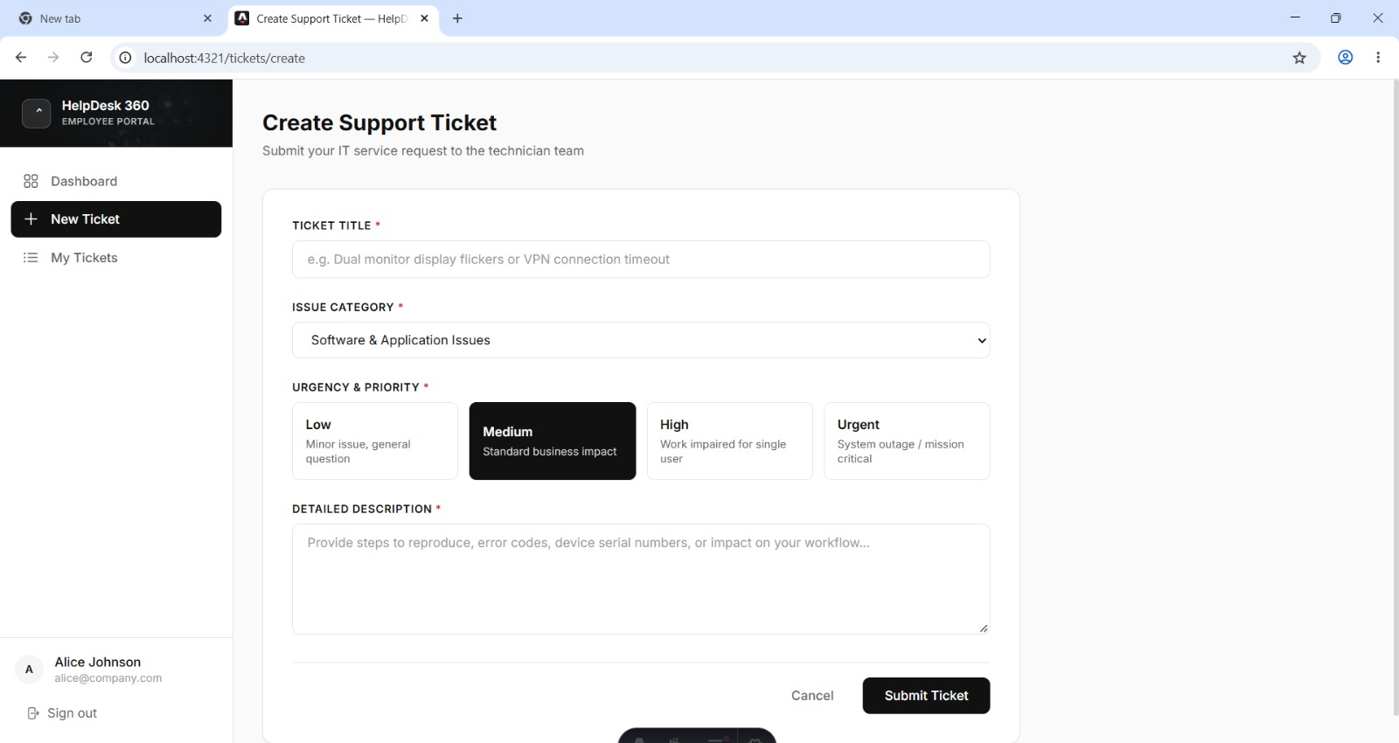
Figure 3. Ticket submission form with category selector and priority cards.

2.2 Prioritization and assignment
Rule | Enforced in | How
Four priority levels (Urgent, High, Medium, Low) | Backend | Enum + mapping from the original dataset (Critical → URGENT)
Only technicians see the full queue and can filter | Backend + Frontend | GET /api/tickets is technician-only; UI has Priority + Status filters
A ticket can stay unassigned | Database | assigned_to is a nullable foreign key
Claiming assigns the ticket and moves it to IN_PROGRESS | Frontend + Backend | “Claim Ticket” button calls PATCH; server sets assignee and status
Only technicians can reassign, and only to technicians | Backend | PATCH is technician-only; assignee list comes from technicians endpoint

2.3 Status tracking
Rule | Enforced in | How
Status is one of OPEN, IN_PROGRESS, RESOLVED, CLOSED | Backend | Ticket.Status enum (dataset “New” maps to OPEN)
Technicians change status; a reporter may close their own ticket | Backend | Authorisation check for technician role or reporter-close
Every status change is recorded with who, when, old and new status | Backend | A status_history row is written for each transition
History cannot be edited or deleted | Database + Backend | Append-only design — no update or delete path exists
Dashboard counts are always current | Backend | Aggregates run directly from the database on every request
⚠ TEAM TO CONFIRM before submitting: (1) Does the backend reject invalid transitions (e.g. CLOSED → OPEN)? State yes or no, and where. (2) Is the “technician only” rule on PATCH enforced by Spring Security, a service-level check, or both?

3. Methods
Here’s what we decided and why:
Decision | What we chose, and why
Stack | Java 21 + Spring Boot 3.2.5 for the API, Astro 7.3 + React 19 + Tailwind 4 for the UI, Maven for builds. Spring Boot gives us dependency injection, JPA transactions and Spring Security in one framework. Astro with React islands keeps pages light while forms and queues stay interactive.
Database schema | Three tables only: users (unique email, password hash, role), tickets (title, description, category, priority, status, reported_by, nullable assigned_to, timestamps) and status_history (ticket, changed_by, old and new status, timestamp). SQLite is the default for zero-setup runs; the same entities work against Supabase PostgreSQL.
Authentication | Email and password login. Passwords stored as BCrypt hashes. Server returns a signed JWT that the frontend sends as a Bearer token. JwtAuthFilter validates it on every request — no server-side session.
Roles | Two roles: EMPLOYEE and TECHNICIAN. All real checks live on the server. The UI only hides controls — it never trusts the frontend for security.
Dashboard counts | Computed on request with database aggregate queries. Nothing is stored or cached, so the numbers can’t drift from the actual data.
Dataset import | A real-world enterprise helpdesk dataset (150 tickets, 29 agents, six GCC countries) was mapped to our enums and loaded as seed data. Agents became TECHNICIAN users with hashed credentials.

Access control matrix
Endpoint | Method | Roles | Purpose
/api/auth/login | POST | Public | Authenticate and receive JWT
/api/health | GET | Public | Health probe
/api/tickets | POST | Employee, Technician | Submit a ticket
/api/tickets/my | GET | Employee, Technician | Own tickets
/api/tickets | GET | Technician | Full queue with filters
/api/tickets/{id} | GET | Employee, Technician | Ticket details
/api/tickets/{id} | PATCH | Technician (or reporter close) | Change status or assignee
/api/tickets/{id}/history | GET | Employee, Technician | Audit trail
/api/tickets/dashboard/metrics | GET | Employee, Technician | Live counts
/api/users/technicians | GET | Technician | List technicians

4. Results
Scenarios 1 to 7 come from the automated JUnit/MockMvc suite (mvn test: 6 tests, 0 failures) and a full browser walkthrough with the demo accounts. Scenarios 8 to 11 are the ones the brief asks for that we still need to run and fill in.
# | Scenario | What happened | OK? | Notes
1 | Health check | Returned {"status":"UP"} | Yes | testHealthCheck
2 | Employee login (alice) | JWT issued with employee role | Yes | testEmployeeLoginSuccess
3 | Technician login (dave) | JWT issued with technician role | Yes | testTechnicianLoginSuccess
4 | Wrong password | HTTP 401, no token | Yes | testLoginInvalidCredentials
5 | New High-priority hardware ticket | HTTP 201; appeared in My Tickets; first history row created | Yes | Test + browser run
6 | Claim → IN_PROGRESS → RESOLVED | Status changed; history held the full sequence | Yes | testTicketLifecycleAndHistory
7 | Dashboard metrics on seeded data | 150 total = 68 open + 28 in progress + 29 resolved + 25 closed; 42 urgent; 146 assigned | Yes | 4 tickets still unassigned
8 | Urgent ticket submitted by employee | [Run and record] | [ ] | Check technician alert banner
9 | Reassignment to another technician | [Run and record] | [ ] | Check a history row is written
10 | Restart the server | [Run and record] | [ ] | Tickets and history should persist
11 | Hostile input (employee PATCH, empty title, long text, script tags) | [Run and record] | [ ] | Expect 403 or 400, never 500
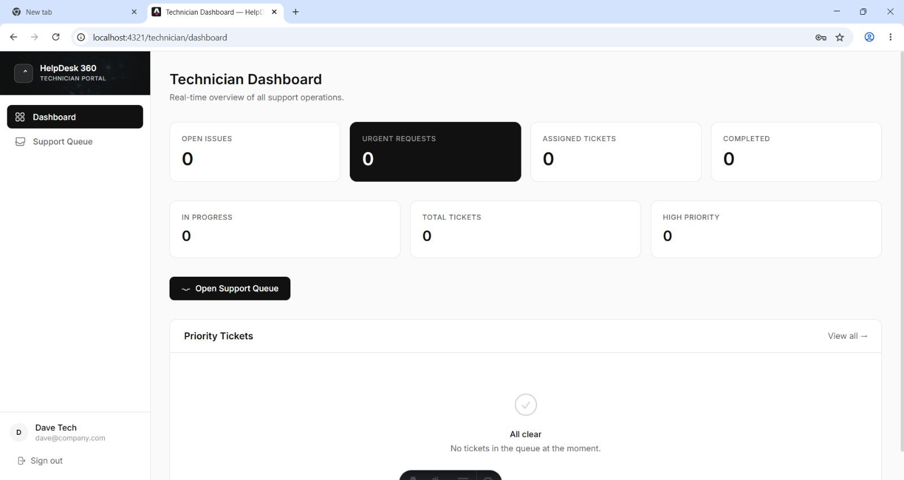
Figure 4. Technician dashboard: eight live metric cards and the Priority Tickets panel.

Bugs and gaps we already know about
These came from reading the system against its own documentation. We still need to confirm each one by testing.
SLA is described but not live.
The dataset carries first-response time, resolution time and SLA met/not met flags. The app reports on them, but no timer or breach alert actually runs on newly created tickets. A ticket left untouched will never raise a warning. The sign-in screen even advertises “Automated SLA Response & Escalation”, so we either need to build it or reword that claim.
Source channel is metadata only.
Email, Chat, Phone and Portal values are kept in ticket metadata and descriptions. There’s no dedicated column, so we can’t filter or count by them.
Dataset “New” collapses into OPEN.
The import maps five source statuses to four enums, so the distinction between untouched and acknowledged tickets is lost.
Thin negative testing.
The 6 automated tests cover the happy path plus one bad login. Nothing yet proves that an employee is blocked from technician endpoints or that invalid transitions are rejected.
⚠ TEAM TO ADD: The real bug or gap you found while building or testing (symptom, cause, fix or why it remains). This is the most valued part of the section.

5. How we worked
Fill this table from your own project notes. Keep it factual — what was planned for each checkpoint and what actually got done.
Part 8 checkpoint | Planned | Actual
Checkpoint 1 | [What you planned] | [What you actually had working]
Checkpoint 2 | [What you planned] | [What you actually had working]
Checkpoint 3 | [What you planned] | [What you actually had working]

One dead end we abandoned
⚠ TEAM TO ADD: Describe one approach you tried and dropped, and why. Possible candidates: the Supabase PostgreSQL path versus staying on SQLite, an earlier UI theme before settling on black-and-white, or a different way of computing dashboard counts.

6. Limitations and next steps
Limitation | Specific next step
No notifications when a ticket is submitted, assigned or resolved | Send an email to the reporter when status becomes RESOLVED, and to the technician when a ticket is assigned (Spring Mail + event listener)
SLA data is analysed, not enforced | Add a due_at column from priority (e.g. Urgent = 4 hours), a scheduled job that flags breaches, and an “At risk” filter in the queue
JWT stored in client storage is readable by any injected script | Move the token to an HttpOnly, Secure, SameSite cookie and add a refresh-token flow
Demo accounts share one password; secrets and Supabase keys are pre-configured | Load JWT secret and database keys from environment variables, remove default passwords outside demo mode
Supabase PostgreSQL path not verified end to end; SQLite allows a single writer | Run the full test suite against PostgreSQL in CI and add Flyway migrations
Only 6 backend tests and no frontend tests | Add MockMvc tests for 403 and 400 cases and invalid transitions, plus Playwright tests for submit and claim flows
Source channel and technician group are not first-class fields | Add channel and agent_group columns and filter + dashboard widgets for them

7. How to run it
Steps for a fresh machine. Commands are shown for Windows PowerShell (the project was built on it). On macOS or Linux just use the same commands in a normal shell.

Prerequisites
• OpenJDK 21 LTS with JAVA_HOME set
• Apache Maven 3.9 or newer on the PATH
• Node.js 20 or 22 with npm

Steps
1. Clone the repository and open a terminal in the project root.
2. Start the backend (first terminal):
cd backend
mvn spring-boot:run
→ API listens on http://localhost:8080/api
3. Check it is up: open http://localhost:8080/api/health — should return {"status":"UP"}.
4. Start the frontend (second terminal):
cd frontend
npm install
npm run dev -- --host 127.0.0.1 --port 4321
→ App available at http://127.0.0.1:4321
5. Open http://127.0.0.1:4321 and sign in with a demo account below.
6. Optional: run the automated tests from backend/ with mvn test (expect 6 tests, 0 failures).

Demo accounts
Role | Email | Password | Use it to
Employee | alice@company.com | password123 | Submit and track tickets
Employee | bob@company.com | password123 | Submit and track tickets
Technician | dave@company.com | password123 | Dashboard, queue, claim, reassign, resolve
Technician (Security) | khalid.al-rashid@company.com | password123 | Dataset agent
Technician (Customer Service) | ahmed.al-nasser@company.com | password123 | Dataset agent
Technician (Development) | mohammed.al-hamdan@company.com | password123 | Dataset agent

Appendix A. Algorithms and engineering principles

A.1 System workflow
Employee submits a ticket → REST API validates input, checks permissions, applies rules → Database (users, tickets, status history) → Technician queue (filter, prioritise, assign) → Dashboard (live database metrics)

A.2 Algorithms
Five algorithms carry the ticket logic. The last column says how far each is evidenced; “Confirm” means check the code and update the wording before submitting.
Algorithm | Purpose and how it works | Complexity | Status
1. Priority sorting | Urgent tickets appear first. Rank (Urgent=1 … Low=4), then by creation time. Done in the database with ORDER BY. | O(n log n) | Confirm: verify default order is urgent-first, then oldest
2. Ticket assignment | Only a technician may assign, and the assignee must also be a technician. Claiming is the same rule with the current user as assignee. | O(1) | In place: claim and reassign through PATCH
3. Lifecycle / state transition | A map of allowed moves keeps status changes valid. Every change writes a history row in the same transaction. | O(1) | Confirm which transitions are rejected
4. Dashboard metrics | Counts calculated by the database on each request, never hardcoded. | O(n) | In place: /api/tickets/dashboard/metrics
5. Employee access control | An employee receives only tickets they reported; a technician receives the whole queue. User id comes from the verified JWT. | O(n) | In place: /api/tickets/my and technician-only GET

Priority sorting (pseudocode)
priority_order = {"URGENT": 1, "HIGH": 2, "MEDIUM": 3, "LOW": 4}
tickets.sort(key=lambda t: (priority_order[t.priority], t.created_at))
-- database equivalent --
ORDER BY CASE priority WHEN 'URGENT' THEN 1 WHEN 'HIGH' THEN 2 WHEN 'MEDIUM' THEN 3 ELSE 4 END, created_at ASC

Status transition (illustrative)
allowed = { "OPEN": {"IN_PROGRESS"}, "IN_PROGRESS": {"RESOLVED"}, "RESOLVED": {"CLOSED", "IN_PROGRESS"}, "CLOSED": set() }
The project also lets a reporter close their own ticket — an exception to the technician-only rule that should be documented wherever the transition map lives.

Dashboard metrics (SQL)
SELECT COUNT(*) FILTER (WHERE status = 'OPEN') AS open_tickets, COUNT(*) FILTER (WHERE priority = 'URGENT' AND status NOT IN ('RESOLVED','CLOSED')) AS open_urgent, COUNT(*) FILTER (WHERE assigned_to IS NOT NULL) AS assigned, COUNT(*) FILTER (WHERE status IN ('RESOLVED','CLOSED')) AS completed FROM tickets;

A.3 Software engineering principles
Principle | How HelpDesk 360 applies it | Status
Separation of concerns | Frontend handles interaction, Spring Boot handles business rules and authorisation, database stores records. | In place
Modularity | Controllers handle HTTP, services hold the rules, repositories reach the database. | In place
Data integrity | Unique email, NOT NULL reporter, foreign keys. Tickets survive a refresh and a backend restart. | In place; restart test pending
Least privilege | Each role gets only the access it needs, enforced in Spring Security — not just by hiding buttons. | In place
Auditability | Every status change stores who, when, old and new status in an append-only history table. | In place
Input validation | Reject missing titles, invalid categories, unsupported priorities and unauthorised requests (400 / 403). | Form checks in place; verify 400/403
Single source of truth | The database is the only source for ticket data and dashboard metrics. | In place
Atomicity | Save the status change and its history row in one transaction. | Confirm the transaction boundary
Server-side UTC timestamps | Timestamps generated on the server in UTC for consistent records. | Confirm
Environment-based config | Keep database credentials and the JWT secret out of source code. | Not yet
Testing | Test creation, authorisation, status transitions, persistence and metric calculations. | Partial: 6 backend tests
DRY | Reuse validation and business logic across endpoints instead of copying it. | Confirm

A.4 Complexity summary
Let n be the number of tickets. These are typical estimates, not guaranteed timings.
Operation | Typical complexity | Reason
Sort all tickets | O(n log n) | Comparison-based sorting
Filter tickets in memory | O(n) | Examine each ticket
Count dashboard metrics | O(n) without useful indexes | Examine the relevant rows
Find a ticket by indexed id | About O(log n) | B-tree index lookup
Update one ticket | Depends on indexes and constraints | Find the row, then update it
— End of Report —

